 | SAKR MANNING AGENCY  FOR RECRUITING EGYPTIAN LABOR ABROAD | Issue Date | 15.05.2022
 |  | Revision Date | 19.07.2022
 | Crewing Management Manual  Seafarer Employment Application | Revision | 1.1
 |  | Page | 3

Application For Position as | 2nd ENGINEER
Register Code. | EO-2.013
Other Position (If Any)
Register Date | 19/2/2023
Last up Date Data
Expected Salary

1. PERSONAL DETAILS
Full Name |  | HAMED BERSY HUSSIEN MESAFER
Date Of Birth |  | 17/09/1986 |  |  |  |  |  |  | Place Of Birth |  |  |  |  |  |  |  | ALEXANDRIA
Nationality |  | EGYPTIAN |  |  |  |  |  |  | Marital Status |  |  |  |  |  |  |  | Single ☐ |  |  |  |  |  |  |  | Married ☐
Height (Cm) |  | 180 |  |  |  |  |  |  | Overall Size |  |  |  |  |  |  |  | 3XL |  |  |  |  | Shirt Size |  |  |  |  |  | 3XL
Weight (Kg) |  | 90 |  |  |  |  |  |  | Trouser Size |  |  |  |  |  |  |  | 36 |  |  |  |  | Shoes Size |  |  |  |  |  | 43
2. EDUCATION
College / School
Marline Test |  | Issued Date |  |  |  |  | Result % |  |  |  | Issued By (Authority) |  |  |  |  |  |  |  |  |  | Issued At
English Language |  | Fluent |  |  |  |  |  | Good |  |  |  |  | Average |  |  |  |  |  |  |  | Poor
……… Language  ( ) |  | Fluent |  |  |  |  |  | Good |  |  |  |  | Average |  |  |  |  |  |  |  | Poor
3. CONTACT DETAILS
Home Address / City |  |  | ALEXANDRIA
E-Mail |  |  | ENGHAMEDBARSI@GMAIL.COM |  |  |  |  |  |  | Mobile / Tel |  |  |  |  |  | 01288025456 |  |  |  |  |  |  | 01277140895

4. TRAVEL DOCUMENTS
Type |  | Document No. |  |  |  | ISS. Date |  |  | Exp. Date |  |  |  |  | ISS. By (Authority) |  |  |  |  |  |  |  |  |  | Place of Issue
Passport |  | A21568304 |  |  |  | 15/11/2017 |  |  | 14/11/2024 |  |  |  |  | Egyptian Authority |  |  |  |  |  |  |  |  |  | Alex.
Seaman Book |  | S00012934 |  |  |  | 04/02/2021 |  |  | 20/12/2025 |  |  |  |  | EAMS |  |  |  |  |  |  |  |  |  | Alex.
Other Seaman Book |  | PA0295588 |  |  |  | 12/08/2022 |  |  | 20/12/2025 |  |  |  |  | panama authority |  |  |  |  |  |  |  |  |  | greece

5. PROFESSIONAL QUALIFICATION / CERTIFICATE OF COMPETENCY
Certificate Name |  |  |  |  | Number | Issue Date |  |  |  |  |  | Expiry Date |  |  |  |  |  | Issued By |  |  |  |  |  |  |  |  | Issued At
COC |  |  |  |  | 4799 | 04/02/2021 |  |  |  |  |  | 20/12/2025 |  |  |  |  |  | EAMS |  |  |  |  |  |  |  |  | Alex.
GOC |  |  |  |  |  |  |  |  |  |  |  |  |  |  |  |  |  | NTRA |  |  |  |  |  |  |  |  | Cairo
D.P. INDUCTION
D.P. ADVANCED
D.P. OPERATOR (UNLIMITED)
6. NEXT OF KIN
Full Name | mahmoud bersy hussien |  |  |  |  |  |  |  |  |  |  |  |  |  | Relationship |  |  |  |  | brother
Address | alexandria
Tel. No. |  |  |  |  |  |  |  |  |  | Mobile |  |  | 01200869002
7. HEALTH CERTIFICATES & VACCINATIONS
Flag State |  |  |  | Number |  |  | Issue Date |  |  |  |  | Expiry Date |  |  |  |  |  |  | Issued By |  |  |  |  |  |  | Issued At
International Medical |  |  |  | 10612 |  |  | 1/02/2023 |  |  |  |  | 31/01/2025 |  |  |  |  |  |  | EAMS |  |  |  |  |  |  | Alex.
Yellow Fever |  |  |  |  |  |  | 07/05/2008 |  |  |  |  |  |  |  |  |  |  |  | Ministry of Health
Cholera |  |  |  |  |  |  |  |  |  |  |  |  |  |  |  |  |  |  | Ministry of Health
Covid-19 |  |  |  | Vaccination Name |  |  | First Dose |  |  |  |  | Second Dose |  |  |  |  |  |  | (Other Does or Remarks)
 |  |  |  | JOHNSON AND JOHNSON |  |  | 28/12/2021 |  |  |  |  | XXXXXX

8. MARINE COURSES
Course Name | Number | Issue Date | Expiry Date | Issued By / At
Personal Survival Techniques
Proficiency In Personal Survival Techniques | NPST 3292 | 17/01/2021 | 12/01/2026 | EAMS ALEX.
Fire Prevention and Fire Fighting
Advanced Fire Prevention and Fire Fighting | NAFF1230 | 17/01/2021 | 03/01/2023 | EAMS ALEX.
Elementary First Aid | NFA3443 | 17/01/2021 | 08/01/2026 | EAMS ALEX.
Medical Care Studies
Personal Safety and Social Responsibilities | NPS3586 | 17/01/2021 | 03/01/2026 | EAMS ALEX.
Proficiency Of Security Awareness Training Seafarers | NA4465 | 12/01/2021 | 09/01/2026 | EAMS ALEX.
Proficiency as a ship Security officer ( PSSO )
Proficiency In Survival Craft & Rescue Boats | NC23162 | 17/01/2021 | 09/01/2026 | EAMS ALEX.
G.M.D.S.S
Communications
Advanced Communications
ECDIS Advanced Simulator (Management Level)
ECDIS Simulator (Operation Level)
Prevention and Combating of Marine Pollution
Radar & ARPA Simulator and Search &rescue
ARPA Simulator and Search
Marine Radar and automatic Radar Plotting
Bridge resource Management (B.R.M)
Engine resource Management (E.R.M)
Navigational Watch keeping
Proficiency for Rating forming part of Navigational watch (II/4) |  |  |  | EAMS / Alex.
High voltage training – operation of ship (1000 Volt and More)
Passenger Safety Cargo Safety and Hull integrity | NXD917 | 21/01/2021 | 23/10/2024 | EAMS ALEX.
Crowd Management Training | NXA909 | 21/01/2021 | 18/10/2024 | EAMS ALEX.
Crisis Management and Human Behavior Training | NXB946 | 21/01/2021 | 20/10/2024 | EAMS ALEX.
Safety training for Personal Prov. Direct Passengers | NXC932 | 21/01/2021 | 22/10/2024 | EAMS ALEX.
Practical Ability to Prepare Meals and (MLC 2006)
Personal Hygiene and Envir. Protection (MLC 2006)
Safety and Health in the Provision Meals (MLC 2006)
Food Storage and inventory Control (MLC 2006)
Ships Cook Certificate (MLC 2006) |  |  |  | EAMS / Alex.
Abel Seafarer Deck
Proficiency for Abel Seafarer Deck ( II/5 ) |  |  |  | EAMS / Alex.
Engineering Watch keeping |  |  |  | EAMS / Alex.
Proficiency for Rating forming part of a watch in engine room
Abel Seafarer Engine
Proficiency for Abel Seafarer Engine ( III/5 ) |  |  |  | EAMS / Alex.
Electro Technical Rating
Proficiency for Electro Technical rating ( III/7 ) |  |  |  | EAMS / Alex.

 | 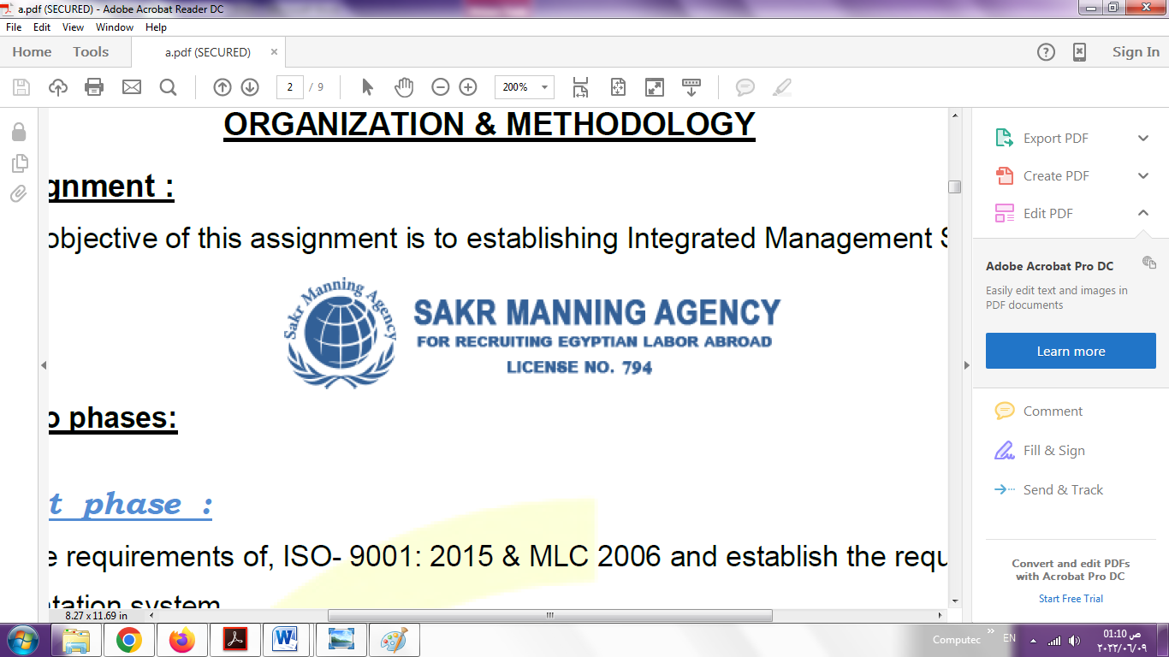 |  | 9 - COMPLETE SEA – SERVICE DETAILS
 | Name: |  | Hamed Bersy Hessien Mesafer |  |  |  |  |  |  |  |  | Rank: |  | 2nd ENG |  |  | Register Code:
 | Company Name |  |  |  | Rank |  | Vessel Name/IMO Number |  | Flag |  | Signed On |  |  | Signed Off |  |  | Period |  |  | Vessel Type |  |  | D.W.T./ G.R.T |  |  | Engine Type |  | BH/ KW |  |  | Reason for Sign off
 | AL-Baharia CO. |  |  |  | 2ND Eng |  | Falcon UA/ 8300327 |  | PALAU |  | 29/11/2023 |  |  | 06/01/2024 |  |  | 1 M / 9 D  39 DAYS |  |  | Reefer |  |  | 1700  /2462 |  |  | MAN B&W |  |  |  |  | Entering a port where a war
 | Mahony Group |  |  |  | 2nd Eng |  | Egy Crown/ 9216107 |  | EGYPT |  | 07/04/2023 |  |  | 13/10/2023 |  |  | 6 M / 6 D  189 DAYS |  |  | Container |  |  | 18425  /14241 |  |  | MAN B&W |  | 13413 |  |  | END OF CONTRACT
 | Delmar Marine |  |  |  | 2nd Eng |  | OTS-Yeoman/  7114197 |  | PANAMA |  | 18/12/2022 |  |  | 18/01/2023 |  |  | 1 M  31 DAYS |  |  | Offshore DP |  |  | 699  /1300 |  |  | GM EMD 24/30 |  | 2*1875  /2*1397 |  |  | END OF CONTRACT
 | VARIETY Cruises |  |  |  | 2nd Eng |  | to-Callisto/  5416553 |  | PANAMA |  | 12/04/2022 |  |  | 16/11/2022 |  |  | 7 M / 4 D  218 DAYS |  |  | Passenger |  |  | 99  /499 |  |  | MTM |  | 3100 |  |  | END OF CONTRACT
 | United Marine Egypt |  |  |  | 2nd Eng |  | EL-Gouna Trader/  8420426 |  | CYPRUS |  | 24/08/2021 |  |  | 27/12/2021 |  |  | 4M / 3D  132 DAYS |  |  | RORO |  |  | 3969  /7095 |  |  | Wartisilla 2990 |  | 4330  /3030 |  |  | END OF CONTRACT
 | United Marine Egypt |  |  |  | 2nd Eng |  | EL-Gouna Trader/  8420426 |  | CYPRUS |  | 26/03/2021 |  |  | 29/06/20021 |  |  | 3 M / 3 D  95 DAYS |  |  | RORO |  |  | 3969  /7095 |  |  | Wartisilla 2990 |  | 4330  /3030 |  |  | END OF CONTRACT
 | United Marine Egypt |  |  |  | 2nd Eng |  | EL-Gouna Trader/  8420426 |  | CYPRUS |  | 13/11/2019 |  |  | 25/11/2020 |  |  | 12M/12 D  378 DAYS |  |  | RORO |  |  | 3969  /7095 |  |  | Wartisilla 2990 |  | 4330  /3030 |  |  | END OF CONTRACT
 | RASHIED Maritime |  |  |  | 3rd Eng |  | Victoria 2/  9789609 |  | jordan |  | 25/01/2019 |  |  | 09/02/2019 |  |  | 15 days |  |  | Offshore Supply |  |  | 81  /273 |  |  | Yanmar |  | 2200  *3  /1641 |  |  | END OF CONTRACT
 | RASHIED Maritime |  |  |  | 3rd Eng |  | Victoria 2/  9789609 |  | jordan |  | 10/12/2018 |  |  | 05/01/2019 |  |  | 25 days |  |  | Offshore supply |  |  | 81  /273 |  |  | Yanmar |  | 2200*3  1641 |  |  | END OF CONTRACT
 | Goltens Company |  |  |  | maintenance supervisor |  |  |  |  |  | 01/11/2015 |  |  | 01/08/2017
 | 10. REFERENCES
 | No | Company / Management / Country |  |  |  |  |  |  |  |  |  | Position |  |  |  | Name |  |  |  |  | TEL |  |  |  | EMAIL
 |  | Variety cruises/ greece |  |  |  |  |  |  |  |  |  | Engineering Inspector |  |  |  | Thomas |  |  |  |  | +306945335127
11. DECLARATION
Please answer the following questions:
- Did you suffer, or presently suffer from, any disease likely to render you unfit for services at sea or likely to endanger the health of other persons on board?  If yes, please provide details _______________________________________________  ______________________________________________________________________ | ☐YES ☒NO
- Did you suffer any accident, which rendered you temporary and/or partially disabled? | ☐YES NO
- Did you ever undergo psychiatric treatment | ☐YES ☒NO
- Are you addicted to alcohol or drugs of any kind? | ☐YES ☒NO
I hereby declare that the above facts and information are true and accurate. I further consent to the holding and processing by (i) the owners of any vessel on which I may be assigned from time to time and (ii) the Managers and any direct or indirect parent or subsidiary or associated or affiliated company of the Managers (together referred to as "the Companies") for the purposes of my employment, of personal data about me contained herein, or provided to any of the Companies at a later date, including with respect to personal and pensions administration, employee management and as required to comply with any laws, regulations or contracts applicable to any of the Companies or their businesses. I understand that this data will be stored in the Managers’ database for the purposes of my current or future employment arranged by the Managers. Further, I confirm that the above may involve the transfer of my personal data within the Managers’ organization.
Place___________________________ Date __26/02/2024_________________________ Signature ___Hamed Bersy___________________________
 |  |  |  |  |  |  |  |  |  |  |  |  |  |  | DATE |  |  |  |  |  |  |  |  | SIGNATURE

